**WEEK 2-PL/SQL PROGRAMMING**

**SUPERSET ID:6383615**

**EXERCISE 1-CONTROL STRUCTURES**

**SCENARIO 1**

CREATE TABLE bank_customers (

   customer_id     NUMBER PRIMARY KEY,

   name            VARCHAR2(50),

   age             NUMBER,

   balance         NUMBER,

   interest_rate   NUMBER(5,2),

   isVIP           VARCHAR2(5)

);

INSERT INTO bank_customers VALUES (1, 'Alice', 65, 12000, 7.5, 'FALSE');

INSERT INTO bank_customers VALUES (2, 'Bob', 45, 8000, 6.0, 'FALSE');

INSERT INTO bank_customers VALUES (3, 'Charlie', 70, 15000, 8.0, 'FALSE');

INSERT INTO bank_customers VALUES (4, 'David', 30, 5000, 5.5, 'FALSE');

COMMIT;

/

select * from bank_customers;

**INITIAL TABLE**

BEGIN

   FOR customer_rec IN (

      SELECT customer_id

      FROM bank_customers

      WHERE age > 60

   ) LOOP

      UPDATE bank_customers

      SET interest_rate = interest_rate - 1

      WHERE customer_id = customer_rec.customer_id;

   END LOOP;

   COMMIT;

END;

/

select * from bank_customers;

**OUTPUT FOR SCENARIO 1**

**SCENARIO 2**

BEGIN

   FOR customer_rec IN (

      SELECT customer_id

      FROM bank_customers

      WHERE balance > 10000

   ) LOOP

      UPDATE bank_customers

      SET isVIP = 'TRUE'

      WHERE customer_id = customer_rec.customer_id;

   END LOOP;

   COMMIT;

END;

/

SELECT

   customer_id, name, age,  balance,  interest_rate, isVIP

FROM

   bank_customers

ORDER BY

   customer_id;

**OUTPUT FOR SCENARIO 2**

**SCENARIO 3**

ALTER TABLE bank_customers ADD (due_date DATE);

UPDATE bank_customers SET due_date = SYSDATE + 10 WHERE customer_id = 1;

UPDATE bank_customers SET due_date = SYSDATE + 35 WHERE customer_id = 2;

UPDATE bank_customers SET due_date = SYSDATE + 5  WHERE customer_id = 3;

UPDATE bank_customers SET due_date = SYSDATE - 2  WHERE customer_id = 4;

COMMIT;

BEGIN

   FOR cust_rec IN (

      SELECT name, due_date

      FROM bank_customers

      WHERE due_date BETWEEN SYSDATE AND SYSDATE + 30

   ) LOOP

      DBMS_OUTPUT.PUT_LINE(

         'Reminder: Loan for ' || cust_rec.name ||

         ' is due on ' || TO_CHAR(cust_rec.due_date, 'DD-MON-YYYY')

      );

   END LOOP;

END;

/

**OUTPUT FOR REMINDER**

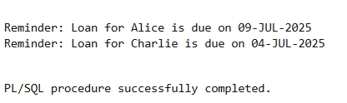

SELECT

   customer_id,

   name,

   age,

   balance,

   interest_rate,

   isVIP,

   TO_CHAR(due_date, 'DD-MON-YYYY') AS due_date

FROM

   bank_customers

ORDER BY

   customer_id;

**FINAL TABLE OUTPUT FOR SCENARIO 3**

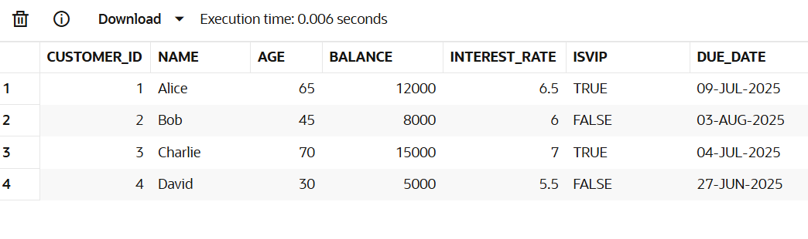

**EXERCISE 3-STORED PROCEDURES**

**SCENARIO 1**

CREATE TABLE savings_accounts (

   account_id    NUMBER PRIMARY KEY,

   customer_name VARCHAR2(50),

   balance       NUMBER(10, 2)

);

/

INSERT INTO savings_accounts VALUES (101, 'Arun', 10000);

INSERT INTO savings_accounts VALUES (102, 'Aravind', 7500);

INSERT INTO savings_accounts VALUES (103, 'Ram', 15000);

COMMIT;

/

select * from savings_accounts;

**

CREATE OR REPLACE PROCEDURE ProcessMonthlyInterest IS

BEGIN

   UPDATE savings_accounts

   SET balance = balance + (balance * 0.01);

   COMMIT;

END;

/

EXEC ProcessMonthlyInterest;

**OUTPUT FOR SCENARIO 1**

**SCENARIO 2**

CREATE TABLE employees (

   emp_id      NUMBER PRIMARY KEY,

   name        VARCHAR2(50),

   department  VARCHAR2(30),

   salary      NUMBER(10, 2)

);

/

INSERT INTO employees VALUES (1, 'Arun', 'HR', 40000);

INSERT INTO employees VALUES (2, 'Aravind', 'IT', 50000);

INSERT INTO employees VALUES (3, 'Ram', 'IT', 60000);

COMMIT;

/

SELECT * FROM employees ORDER BY emp_id;

**INITIAL TABLE**

CREATE OR REPLACE PROCEDURE UpdateEmployeeBonus (

   dept_name IN VARCHAR2,

   bonus_percent IN NUMBER

) IS

BEGIN

   UPDATE employees

   SET salary = salary + (salary * bonus_percent / 100)

   WHERE department = dept_name;

   COMMIT;

END;

/

EXEC UpdateEmployeeBonus('IT', 10);

SELECT * FROM employees ORDER BY emp_id;

**OUTPUT FOR SCENARIO 2**

**SCENARIO 3**

CREATE TABLE accounts (

   account_number NUMBER PRIMARY KEY,

   customer_name  VARCHAR2(50),

   balance        NUMBER(10, 2)

);

/

INSERT INTO accounts VALUES (201, 'Arun', 8000);

INSERT INTO accounts VALUES (202, 'Aravind', 5000);

INSERT INTO accounts VALUES (203, 'Ram', 9000);

COMMIT;

/

SELECT * FROM accounts;

**INITIAL TABLE**

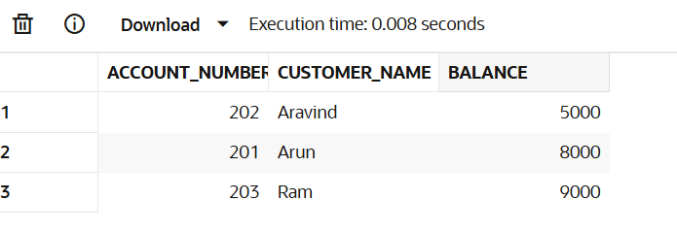

CREATE OR REPLACE PROCEDURE TransferFunds (

   from_account IN NUMBER,

   to_account IN NUMBER,

   amount IN NUMBER

) IS

   insufficient_balance EXCEPTION;

   curr_balance NUMBER;

BEGIN

   SELECT balance INTO curr_balance FROM accounts WHERE account_number = from_account;

   IF curr_balance < amount THEN

      RAISE insufficient_balance;

   END IF;

   UPDATE accounts

   SET balance = balance - amount

   WHERE account_number = from_account;

   UPDATE accounts

   SET balance = balance + amount

   WHERE account_number = to_account;

   COMMIT;

EXCEPTION

   WHEN insufficient_balance THEN

      DBMS_OUTPUT.PUT_LINE('Error: Insufficient balance in source account.');

   WHEN NO_DATA_FOUND THEN

      DBMS_OUTPUT.PUT_LINE('Error: Account not found.');

   WHEN OTHERS THEN

      DBMS_OUTPUT.PUT_LINE('Unexpected error: ' || SQLERRM);

END;

/

EXEC TransferFunds(201, 202, 3000);

SELECT * FROM accounts ORDER BY account_number;

**OUTPUT FOR SCENARIO 3(AMOUNT TRANSFERRED FROM ARUN TO ARAVIND)**

